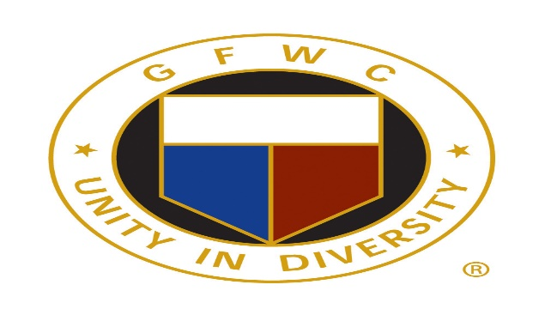

GFWC Woman’s Club of Westminster, Inc.
Press Release
Contact Lynn Wheeler
gfwcwestminster@gmail.com
May 9, 2019
Four Past Presidents of GFWC Woman’s Club of Westminster, Inc. honored for service
Four past presidents and longstanding members of the GFWC Woman’s Club of Westminster, Inc. were honored at a meeting on April 9, 2019.
Betty Mathias, age 97, served as President from 1965-1968. Ms. Mathias, whose family founded Mathias Monuments in Westminster, has lived in the same house for 70 years. She has been a volunteer at the Carroll Hospital gift shop for 25 years.
Lura Griswold served as president from 1972-1974. She has lived in the same farmhouse in Westminster since 1956. A world traveler, Griswold has climbed Mt. Kilimanjaro in Tanzania, and trekked in Nepal. She is a past president of the Carroll Garden Club.
Jackie Hering served as president from 1976-1978. She was a “Spy Lady” at Lewis Hall, McDaniel College. Hering heads up the Education Committee for the Woman’s Club.
Sally Marks served as president from 1990-1992. She is a retired science teacher and longtime volunteer at the Brethren Service Center.
GFWC Woman’s Club of Westminster, Inc. is a nonprofit organization that brings women together in a collective effort to strengthen communities and enhance the lives of others through volunteer service.
Visit our website at www.gfwcmd.org/clubs/western/westminster.womans.html

